**Niedersachsen region, Germany** chosen for the research.

**Variable**: kindergartens (shape files of kindergartens)

In previous homework I’ve used fertility rate as observed variable so now I’m going to use these 2 variables as dependent and independent

Region on the Germany map

First loading all points of interest:

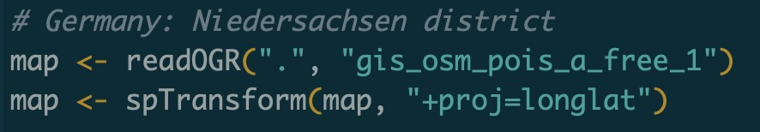

Selecting only kindergartens:

map with all shape points selecting only kindergartens data

plotting all values including non-unique after excluding non-unique values

Loading my region with bbox:

plotting all kindergartens on the map:

